**Risk Management Plan**



**SRM System**

**HIT Team**

Information of document

|  |  |
| --- | --- |
| Title | Risk Management Plan |
| Author(s) | All team |
| Reviewer(s) | All team |
| Team name | HIT Team |
| Team members | Thanh Giang, Hiep Ta, Phuc Nguyen, Giang Nguyen, Dat Tran, Huy Huynh |
| Project mentors | Mr. Hung Anh |
| Editor |  |
| Type of report | Risk Management Plan |
| Software used | MS Word |

Document Reviewer Information

|  |  |  |
| --- | --- | --- |
| Reviewer Name | Review Attendance (R/S) | Comments |
|  |  |  |
|  |  |  |
|  |  |  |

Document Approver Information

|  |  |  |
| --- | --- | --- |
| Approver Name | Approver Function | Comments |
|  |  |  |
|  |  |  |
|  |  |  |

Document Revision History

|  |  |  |  |  |
| --- | --- | --- | --- | --- |
| Date | Revision | Status | Change Summary | Revised by |
| 20/06/2012 | 1.0 |  | Write Risk Plan Draft | Thanh Giang |
| 06/07/2012 | 1.1 |  | Modify risk Plan | Hiep Ta |
| 08/07/2012 | 1.2 |  | Modify risk plan | Hiep Ta |
|  |  |  |  |  |

# Table of Contents

1. Introduction of Document 5

2. Risk Management Process 6

2.1. General Risk Management Process 6

2.2. Detailed Risk Management Process for SRM 8

2.3. Risk Management Roles and Responsibilities 9

2.4. Risk priority: 10

2.4.1. Estimating Probability of loss 11

2.4.2. Estimating Size of loss 11

2.4.3. Risk Exposure 12

2.4.4. Priority of risk 12

3. Top Risk of SRM 14

# Introduction of Document

A risk is an event or condition that, if it occurs, could have a positive or negative effect on a project’s objectives. Risk Management is the process of identifying, assessing, responding to, monitoring, and reporting risks. This Risk Management Plan defines how risks associated with the SRM Project will be identified, analyzed, and managed. It outlines how risk management activities will be performed, recorded, and monitored throughout the lifecycle of the project and provides templates and practices for recording and prioritizing risks.

The Risk Management Plan is created by the project manager in the Planning Phase of the Waterfall Model and is monitored and updated throughout the project.

* This document describes the process to:
* Identify risk events and risk owners
* Evaluate risks with respect to likelihood and consequences
* Assess the options for risks and develop mitigation plans
* Track risk mitigation efforts
* Conduct periodic reassessments of project risks

The intended audience of this document is the project team, project sponsor and management.

# Risk Management Process

## General Risk Management Process

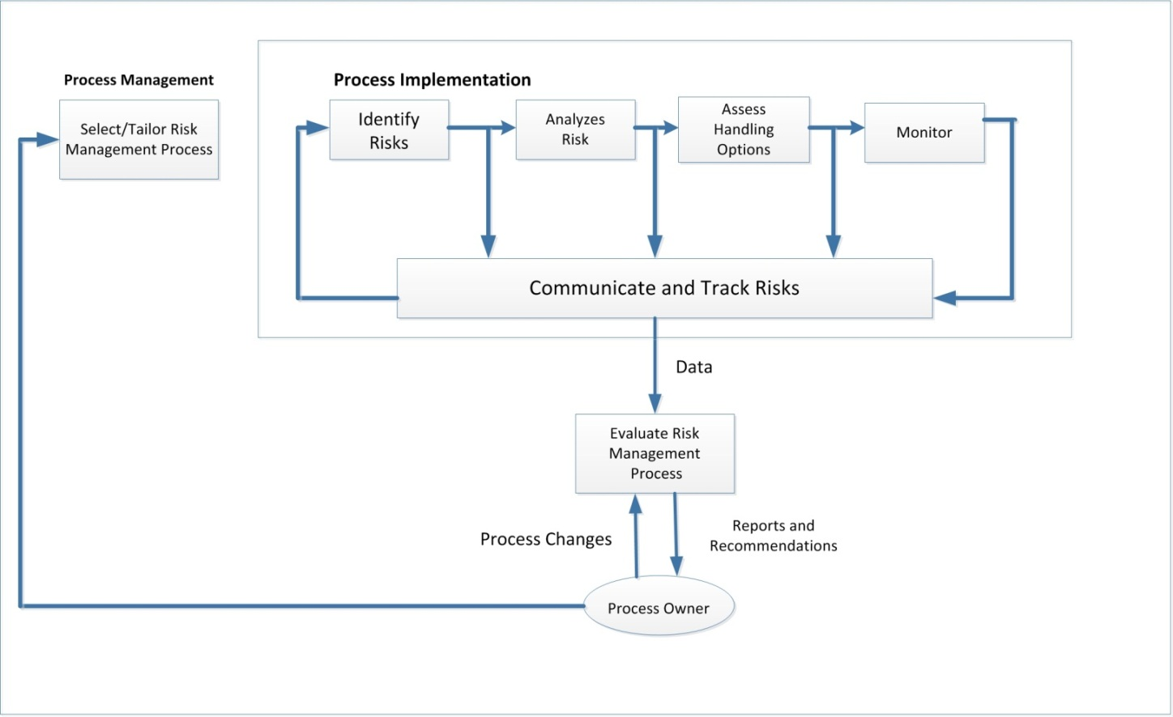The risk management process is comprised of four phases: identification, assessment, handling, and monitoring. (Refer to below Figure) The following paragraphs describe the process used by the project to identify and manage its risk

The following selections describe the suggested risk management process. Project may tailor this process to best meet the needs of the project and/or satisfy the customer. The risk management process includes the following elements:

* Risk Identification- Examine all project elements in detail. Identify, describe, and document cost, schedule, technical, financial, and other risks. Begin the identification process during the capture phase and continue throughout the project life cycle
* Risk Assessment- Evaluate the identified risk for probability of occurrence and potential impact. Estimate project exposure and establish risk handling priorities. Qualitative assessment may be used as an initial filter but all medium and high risks must be assessed quantitatively. Express quantitative assessments (e.g., rough order of magnitude [ROM], range of impact, factored impact, etc.) in terms of dollars, time and performance impact, applicable.
* Risk Handling –Identify risk-handling option (i.e., mitigation, transfer, avoidance, assumption) and action plans, including contingency actions with implementation criteria, decision dates. Assign an owner to each risk and action plan. Ensure that risk handling plans document criteria (i.e., observable, test, date, documentation) that justify the planned, sequential reduction of quantitative risk levels over time
* Risk Monitoring- Track progress against action plans and established metrics to ensure timely completion of actions. Include action plans in the project integrated master schedule (IMS). Include risk name, description, identification date, owner, action plans, milestones, status, and contingency actions in the risk management database. Risk owners must provide status at least monthly.

## Detailed Risk Management Process for SRM

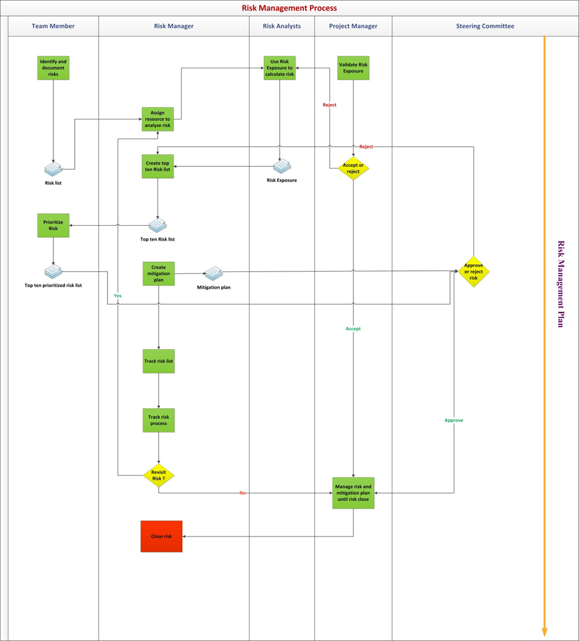

|  |  |
| --- | --- |
| Step | Describe |
| 1 | Any member identifies risks, analyze risk and submit follow form before they become issues or problems. |
| 2 | Project Manager active and create steering meeting |
| 3 | Steering Meeting includes all members in team, and analyzes and proposes mitigation Plan and Contingency plan. On the other hand, if risk is not accepted, it will be rejected. |
| 4 | Track the execution of risk mitigation and risk contingency. |
| 5 | Closed risk if risk control well or risk didn’t happen |

## Risk Management Roles and Responsibilities

|  |  |  |
| --- | --- | --- |
| Roles | Description | Responsible |
| Team member | All the member of the project team | Identify risk in project and prioritize top risk |
| Risk manager | Manager for risk management process | The risk manager is the overall coordinator of the RMP. The risk manager is responsible for the following:   * Maintaining the RMP * Reviewing risk control actions for completeness, feasibility, and adequacy * Evaluating costs associated with risk control actions * Performing risk status accounting * Tracking efforts to reduce medium and high risks to acceptable levels * Providing risk management training * Preparing risk briefings, reports, and documents as required for project reviews |
| Risk Analyst | Specialist in calculate and evaluate risk | Calculate risk impact |
| Project manager | Manager in overall project | Manage risk and concern with the impact of the risk to project also perform mitigation plan if the risk happen |
| Steering committee | Include represent of project team (Risk manager, Project manager) and represent of customer | Make the final decision for which risk must be tracked and the plan to mitigate it. |

|  |  |  |  |
| --- | --- | --- | --- |
| Action | Input | Output | Technique |
| Identify and document risks | Anything related to project | Risk list | Brainstorming  Risk list |
| Assign resource to analyze risk | Risk list | Assignment |  |
| Use Risk Exposure to calculate risk | Risk list  Template for Risk Exposure | Risk Exposure |  |
| Validate Risk Exposure | Risk list  Risk Exposure | Risk Exposure approved |  |
| Create top ten Risk list | Risk list  Risk Exposure | Top ten risk |  |
| Prioritize Risk | Top ten risk | Top ten risk prioritized | Analysis and vote |
| Create mitigation plan | Top ten risk prioritized | Mitigation plan |  |
| Track risk list | Top ten risk prioritized |  |  |
| Track risk process | Risk management plan  Top ten risk prioritized  Mitigation plan |  |  |
| Manage risk and mitigation plan until risk close | Top ten risk prioritized  Mitigation plan | Record for risk happen (if risk is occur) |  |
| Revisit Risk? | Risk management plan  Top ten risk prioritized  Risk list  Mitigation plan |  |  |
| Close risk | Risk management plan  Risk list  Mitigation plan | Closing decision |  |

## Risk priority:

**Goal:** Priority risk

**Question:** How can we priority risk?

**Metric:** Priority rate

Exposure = (total impact level on scope, budget, schedule and quality/4) * Probability

**Impact level:** We define impact level base on 4 factors of project, include: Scope, Budget, Schedule, Quality. The regulations as following table:

|  |  |
| --- | --- |
| Consequence | Value |
| None | 0 |
| Negligible | 1 |
| Marginal | 2 |
| Significant | 3 |
| Critical | 4 |
| Catastrophic | 5 |

### Estimating Probability of loss

In additional, we define the probability of each risk. The detail description as following table:

|  |  |  |  |
| --- | --- | --- | --- |
| No. | Probability | Meaning | Description |
| 1 | 10% | Remote | Risk event not expected to occur |
| 2 | 30% | Unlikely | Risk event less likely occur |
| 3 | 50% | Likely | Risk event may or may not occur |
| 4 | 70% | High Likely | Risk event more likely occur |
| 5 | 90% | Near Certainty | Risk event expected to occur |

### Estimating Size of loss

|  |  |  |  |  |  |
| --- | --- | --- | --- | --- | --- |
| Size of Loss | Consequence | Detailed Regulations | | | |
| Schedule | Budget | Scope | Quality |
| 0.1 | Negligible | Insignificant cost increase | Insignificant cost increase | Scope decrease barely noticeable | Quality degradation barely noticeable |
| 0.3 | Marginal | <5% time increase | <10% cost increase | Minor areas of scope affected | Only very demanding applications are affected |
| 0.5 | Significant | 5-10% time increase | 10-20% cost increase | Major areas of scope affected | Quality reduction requires sponsor approval |
| 0.7 | Critical | 10-20% increase | 20-40% cost increase | Scope reduction unacceptable with sponsor | Quality reduction unacceptable with sponsor |
| 0.9 | Catastrophic | >20% increase | >40% increase | Project end item is effective useless | Project end item is effective useless |

### Risk Exposure

SRM is a mass product so quality is the most importance factor that we must focus on. If the Exposure index is equal with each other, which one have higher impact on quality will have higher priority.

RE= Probability of loss * size of loss

|  |  |  |  |  |  |  |  |  |  |  |
| --- | --- | --- | --- | --- | --- | --- | --- | --- | --- | --- |
| Probability and impact Matrix | | | | | | | | | | |
| Probability | Threats | | | | | Opportunities | | | | |
| 0.9 | 0.09 | 0.27 | 0.45 | 0.63 | 0.81 | 0.81 | 0.63 | 0.45 | 0.27 | 0.09 |
| 0.7 | 0.07 | 0.21 | 0.35 | 0.49 | 0.63 | 0.63 | 0.49 | 0.35 | 0.21 | 0.07 |
| 0.5 | 0.05 | 0.15 | 0.25 | 0.35 | 0.45 | 0.45 | 0.35 | 0.25 | 0.15 | 0.05 |
| 0.3 | 0.03 | 0.09 | 0.15 | 0.21 | 0.27 | 0.27 | 0.21 | 0.15 | 0.09 | 0.03 |
| 0.1 | 0.01 | 0.03 | 0.05 | 0.07 | 0.09 | 0.09 | 0.07 | 0.05 | 0.03 | 0.01 |
|  | 0.1 | 0.3 | 0.5 | 0.7 | 0.9 | 0.9 | 0.7 | 0.5 | 0.3 | 0.1 |

**Using RE to prioritize:** From above two factors, we can define level of each risk.

|  |  |  |  |  |  |
| --- | --- | --- | --- | --- | --- |
| Probability | Consequence | | | | |
| 0.1 | 0.3 | 0.5 | 0.7 | 0.9 |
| 10% | Low | Low | Low | Low | Low |
| 30% | Low | Low | Medium | Medium | Medium |
| 50% | Low | Medium | Medium | Medium | High |
| 70% | Low | Medium | Medium | High | High |
| 90% | Medium | Medium | High | High | High |

### Priority of risk

There are 3 levels that be assessed quantitatively: high, medium and low

A high occurrence of the undesirable event will result in:

* Inability of the system to meet primary functional requirements
* Unacceptable system performance to the customer
* Late system delivery

A medium occurrence of the undesirable event with result in:

* Some system requirement not being met
* A negative impact to particular feature important to the customer
* Major intermediate milestones not being met

A low occurrence of the undesirable event will result in:

* Some system requirements not being met
* Minor degradation of system performance
* Intermediate milestones not being met, therefore, putting a major milestone in jeopardy

Overall risk assessment is the product of combining the probability of occurrence with the severity of impact as follows:

Once the risks are assessed, they are categorized into defined risk categories, providing a means of looking at risks according to their source or taxonomy, and are prioritized form 1 to the n, 1 being the most effective area to which resources for mitigation are applied to achieve the greatest positive impact to the project.

# Top Risk of SRM

Reference to Risk List.xlsx